The purpose of this app is to find and recommend popular or obscure movies to users based on the parameters they chose. The user can input a list of their favorite movies in general or by genre, choose how many recommendations they want, choose the overall popularity of the movies, and then the minimal level of confidence they want the recommendations to be.

Technical summary

To use this app, I have provided screenshots and commentary to help understand and navigate the app.

First, the user can input their favorite movies into the search bar. The user can either scroll through list and find their movie, or they can start typing the name and it will appear. The user can enter as many movies as they want.

Next, the user needs can enter their other parameters such as how many recommendations, the maximum percent of users who have rated the movie (popularity), and the minimum level of confidence (what is the minimum accuracy you want the list of predictions to be). The first two parameters require the user to just enter a number while the last requires the user to use the slider to choose.

Lastly, the user can choose how to sort the results by clicking one of four buttons. Once the user has decided on how to sort the recommendations, all that is left is to click the blue “Recommend Hidden Gems” button.

Once the button is selected, a list of recommendations will populate in the app.

Screenshots of the output for the 5 graded cases in order 1-5

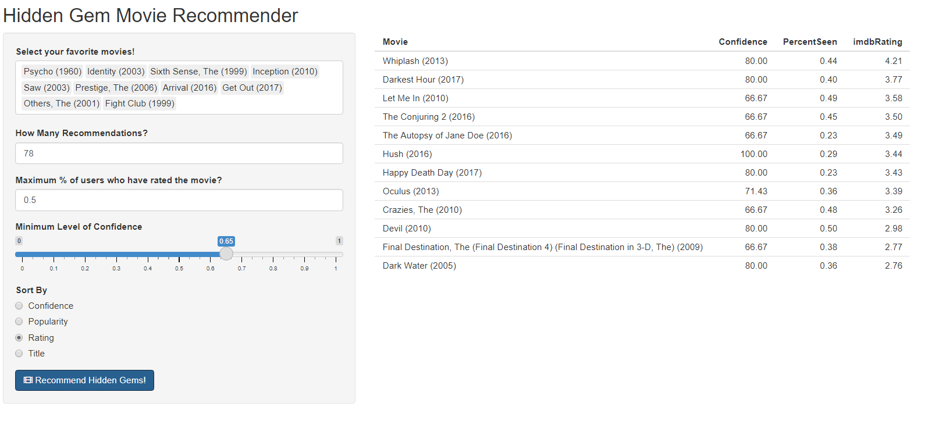

* An example that is relevant to you!

